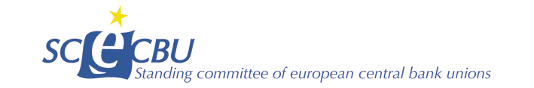.

MTF Working Group/ Cash-handling

Evolution of the cash-handling network

The entire fiduciary sector has undergone major changes for several years, the euro zone countries is impacted at different levels, this survey to provide a little more visibility of each of the countries present in our working group.

Country:

1 - GENERAL VISION
Number of cash center in your country
- Industrial with modern machines
TODAY | 10 years ago | 2000
- Non-modernized local petty cash
TODAY | 10 years ago | 2000

2.- RECYCLING
- Presence of Recycling?
- An idea of the percentage?

- Has the change of habit in the use of cash had an impact in your NCB
go on comments if necessary:

- How many different actors in your fiduciary sector? And which ones?

3.- CONTROL
- Is there a specific service for external controls?

- How many checks per year on average? Machine validity, verification of procedures, etc.
Comments…

- How many persons work on it?
go on comments if necessary:

4.- Banknote accessibility
1. All the regions of your country are well served in cash?
How? (For example: Cash back at merchants; ATMs, private banking, SAB

- What is it your perception about the future of cash

Number of cash centers is including bank´s, CIT´s and NBS´s cash centers.
In 2000 the NBS had 16 cash centers. There was also unspecified number of bank´s cash centers, but this item isn´t relevant and comparable because of the different organization of cash circulation in Slovakia.

